Bahria University,

Karachi Campus



COURSE: CSC-110 COMPUTING FUNDAMENTALS

TERM: FALL 2020, CLASS: BSE- 1 (A,B)

Submitted By:

M Muaz Shahzad 02-131202-081

(Name) (Reg. No.)

Submitted To:

Dr. Salahuddin / Engr. Saniya Sarim

Signed Remarks: Score:

INDEX

|  |  |  |  |  |
| --- | --- | --- | --- | --- |
| SNO | DATE | LAB NO | LAB OBJECTIVE | SIGN |
| 01 | 12-Dec-2020 | 11 | MS One Note |  |
|  |  |  |  |  |
|  |  |  |  |  |
|  |  |  |  |  |
|  |  |  |  |  |
|  |  |  |  |  |
|  |  |  |  |  |
|  |  |  |  |  |
|  |  |  |  |  |
|  |  |  |  |  |
|  |  |  |  |  |
|  |  |  |  |  |
|  |  |  |  |  |
|  |  |  |  |  |
| SNO | DATE | LAB NO | LAB OBJECTIVE | SIGN |
|  |  |  |  |  |
|  |  |  |  |  |
|  |  |  |  |  |
|  |  |  |  |  |
|  |  |  |  |  |
|  |  |  |  |  |
|  |  |  |  |  |
|  |  |  |  |  |
|  |  |  |  |  |
|  |  |  |  |  |
|  |  |  |  |  |
|  |  |  |  |  |
|  |  |  |  |  |
|  |  |  |  |  |
|  |  |  |  |  |

Bahria University,

Karachi Campus



LAB EXPERIMENT NO.

**11**

LIST OF TASKS

|  |  |
| --- | --- |
| TASK NO | OBJECTIVE |
| 1 | Create a daily routine diary on one note. |
| 2 | Perform the extraction of text from image using One note. |
|  |  |
|  |  |
|  |  |
|  |  |
|  |  |

Submitted On:

Date:

23/12/2020

**Task No. 1: Create a daily routine diary on one note.**

**Solution:**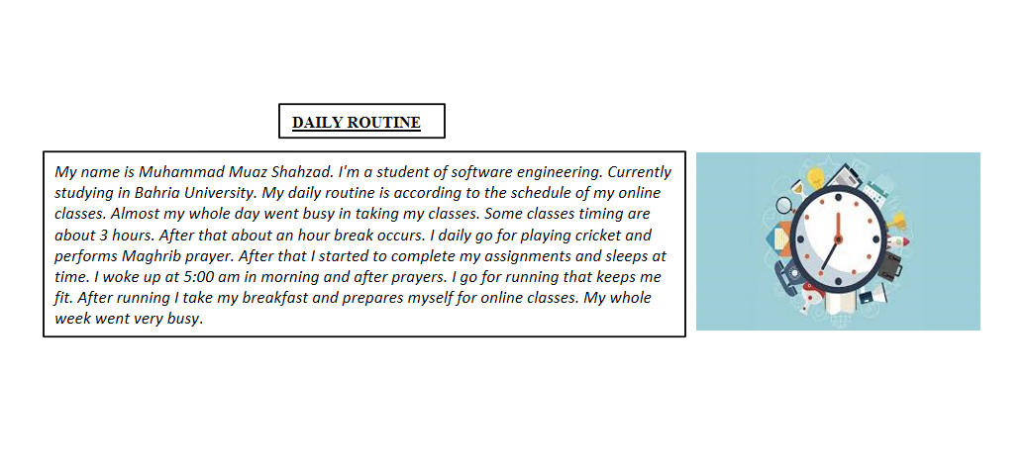

**Task No. 2: Perform the extraction of text from image using One note**.

**Solution:**